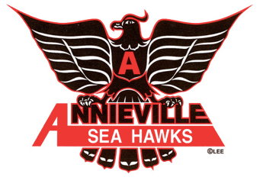
Week at a Glance
September 19-23, 2022

M | September 19 | National Day of Mourning-Schools are Closed.
T | September 20 | PAC Meeting @ 7:15pm in the gym-all are welcome
W | September 21 | Parent Teacher Conferences -Please sign up through Parent Connect  *Early Dismissal @ 1:15pm
T | September 22 | Parent Teacher Conferences -Please sign up through Parent Connect  *Early Dismissal @ 2:00pm
F | September 23 | Pro D Day.  School is not in session. Have a great long weekend!
PAC FB: https://www.facebook.com/groups/1616476022012608

Upcoming Dates:
Sept 20 Pac Meeting @ 7:15pm. Everyone is welcome
Sept 26 Terry Fox Run @ Annieville
Sept 29 Truth and Reconciliation activities @ Annieville-Students wear orange to school
Sept 30 Day for Truth and Reconciliation-Statutory Holiday (Schools closed)

PLEASE READ OVER FOR IMPORTANT INFORMATION:

We start the year with 270 students spread into 12 divisions this year! We do have a couple of staffing updates for you. Ms. Sharma is officially joining us once again this year as our Grade 5/6 teacher. Welcome back, Ms. Sharma!
And in some sad news, Friday, September 23rd will be our Administrative Assistant, Ms. Clarke’s, last day with us. Her warm and welcoming presence will definitely be missed by staff, students and families. Ms. Clarke is returning to her position at ND and we wish her the best!
Our Staff is planning for an exciting year filled with inspiring educational experiences. We look forward to working collaboratively with families to support our learners to achieve their best!

Principal: Ms. Susan Parmar - sparmar@deltaschools.ca
Administrative Assistant: Mrs. Stacey Clarke - sclarke@deltaschools.ca
Div: | Grade | Teacher: | Contact:
1 | 6/7 | Ms. C. Hui | chui@deltaschools.ca
2 | 6/7 | Ms. T. Durman | tdurman@deltaschools.ca
3 | 6/7 | Mrs. J. Goodale | jgoodale@deltaschools.ca
4 | 5/6 | Ms. N. Sharma | nsharma@deltaschools.ca
5 | 4/5 | Ms. S. Gregory | sgregory@deltaschools.ca
6 | 4/5 | Ms. C. Ellis | cmellis@deltaschools.ca
7 | 2/3 | Ms. T. McCullough | tmccullough@deltaschools.ca
8 | 2/3 | Ms. A. Bourhill | abourhill@deltaschools.ca
9 | 1/2 | Ms. S. Pieraccini | spieraccini@deltaschools.ca
10 | 1 | Ms. S. McLean | smclean@deltaschools.ca
11 | KN | Ms. A. Poirier | apoirier@deltaschools.ca
12 | KN | Ms. M. McKay | mamckay@deltaschools.ca
 | Learning Support Team | Ms. A. Hosein | ahosein@deltaschools.ca
 | Learning Support Team | Ms. J. Pixley | jpixley@deltaschools.ca
 | Library/Learning Support Team | Ms. K. Ramsay | kramsay@deltaschools.ca
 | PE Teacher | Mr. A. Sowden | asowden@deltaschools.ca
Education Assistants | H. Behl  D. Kabesh | C. Follett  A. Thiessen | R. Ghoman
 | C. Mitzel | A. Reimer
Noon Hour Supervisors / Crossing Guards | D. May | C. Reed | L. Wilson
Itinerant Staff | Band Teacher | Mr. K. Dibbley | kdibbley@deltaschools.ca
 | Counsellor | Ms. A. Bradley | abradley@deltaschools.ca
 | CYCW | S. Glennon | sglennon@deltaschools.ca
 | Speech and Language Pathologist | N. Piva | npiva@deltaschools.ca
 | District Psychologist | M. Saip | msaip@deltaschools.ca
Custodians |  | Ms. Sidhu

Annieville Crossing Guard Vacancy: We are currently in search of someone to work as the crossing guard for our school. The hours are from 8:25am-8:55am and 3:00-3:30pm. If you are available for morning only or afternoon only, that’s okay too! Please reach out to the Principal, Ms. Parmar, if you are interested or know someone who is. sparmar@deltaschools.ca

Parent Teacher Conferences:
Reminder to families to sign up through Parent Connect for an interview time with your child’s classroom teacher. The link to Parent Connect can be found here. https://www.deltasd.bc.ca/resources/parent-connect/

Please note the two days of early dismissal this week as well. This Wednesday, we will dismiss at 1:15pm and on Thursday, we will dismiss at 2pm.

Parent Connect-Update your forms!
Please log into Parent Connect and respond to the following forms for your student(s):
Demographics, Emergency Release, Fruit & Vegetable Program, Outside Media in School, Personal Information Consent and Walking Field Trip and Google Apps for Education (GAFE).
If any changes are required to Family Demographics or Emergency Release, please send an email to annieville.elem@deltaschools.ca and the office will make the changes.

Upcoming HOT LUNCH Days: A big THANK YOU to our PAC for providing us with hot lunch this year. Always a day our students look forward to!
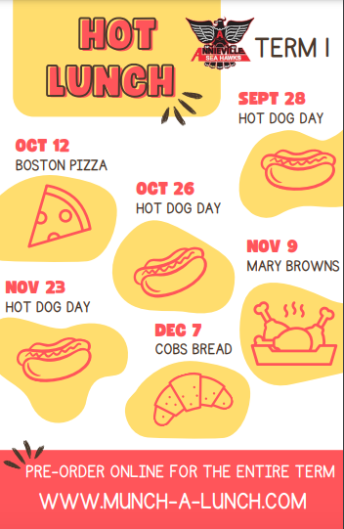
Our Munch-A-Lunch website will be open very soon!

Wednesday September 28th- Hot Dogs
Wednesday, October 12th- Boston Pizza
Wednesday, October 26th - Hot Dogs
Wednesday, November 9th, Mary Browns
Wednesday, November 23rd- Hot Dogs
Wednesday, December 7th - Cobbs

Dressing for the Weather:
Unless there is extreme weather, please expect that our students will be heading outside for recess and lunch throughout the school year. Fresh air and movement allows for a better afternoon of learning. So please ensure your child is prepared for all weather conditions (boots, gloves, toques, umbrellas, etc.)

Health and Wellness
This a gentle reminder for all students, staff, parents and caregivers: Please stay home & away from school if experiencing symptoms of illness. Please be advised that the Daily Health Check has been updated in line with the district’s latest Communicable Disease Prevention Plan. These documents can be found on the COVID page of the district website: https://www.deltasd.bc.ca/news-events/news/information-for-parents-guardians-novel-coronavirus/

